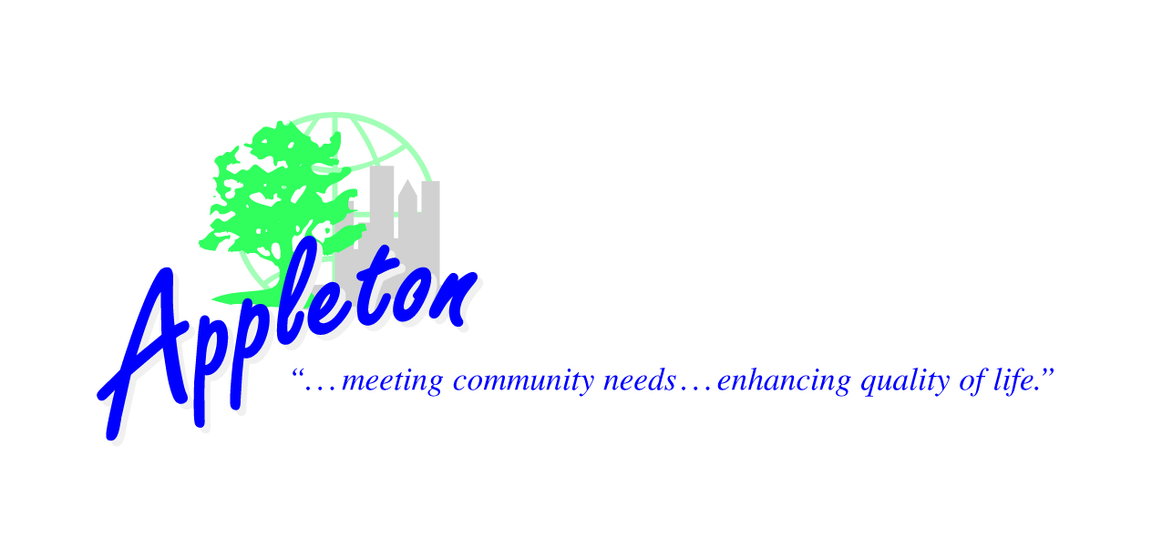
Parks & Recreation
100 North Appleton Street
Appleton, Wisconsin 54911-4799
(920) 832-5905 Fax (920)832-5950
www.appleton.org
PARKS, RECREATION & FACILITIES MANAGEMENT

Bicycle and Pedestrian Advisory Committee

MEETING NOTICE

Thursday, July 21, 2022, 3:00 P.M. – 4:30 P.M.
Parks, Recreation and Facilities Management Department
1819 Witzke Boulevard, Appleton, WI

- Call to Order.

- Committee Member Introduction – Alderperson Denise Fenton

- DPW
- Project Updates
- Highway 41 Overpass Design
- RRFB Warning System Requests

- Parks, Recreation, and Facilities Management
- Ellen Kort Peace Park River Trail
- Project Updates

- A Round the Table

- Future Agenda Items

- Other Business.

- Adjournment.

